Year 7 | Transport, Urban Sprawl and the 20-Minute City | 70 mins | Lesson 4
Learning Intentions | Lesson Outcomes
- Develop an understanding of the relationship between Urban Design and Town Planning and Active Transport  - Develop an understanding of the relationship between Urban Design and Town Planning and Public Transport  - Discuss mixed use development, urban sprawl and its challenges, and the idea of the 20-minute city  - Explore the Urban Planning Game | - Demonstrated understanding of Active transport and how this applies to Urban and Town Planning  - Demonstrated understanding of Public Transport and how this applies to Urban Design and Town Planning  - Understand the importance of mixed use development  - Understand urban sprawl and its challenges and its impacts on Urban Design and Town Planning  - Understand how Sustainable Development Goals may apply to neighbourhood designs
Australian Curriculum Content Descriptions |  | Australian Curriculum General Capabilities
Geographical Knowledge and Understanding  Causes and consequences of urbanisation (ACHGK054)  - discussing urbanisation as a shift in where, how and why people live where they do  - examining how urbanisation can positively or negatively affect environmental quality (for example, carbon emissions and water consumption)  Geographical Inquiry and Skills  Represent spatial distribution of different types of geographical phenomena by constructing appropriate maps at different scales that conform to cartographic conventions, using spatial technologies as appropriate (ACHGS058)  Present findings, arguments and ideas in a range of communication forms selected to suit a particular audience and purpose; using geographical terminology and digital technologies as appropriate (ACHGS061) |  | Personal and Social Capability  Social awareness  - Appreciate diverse perspectives  Ethical Understanding  Understanding ethical concepts and issues  - Explore ethical concepts in context  - Recognise ethical concepts  Reasoning in decision making and actions  - Consider consequences  Exploring values, rights and responsibilities  - Examine values  - Explore rights and responsibilities  - Consider points of view  Critical and Creative Thinking  Inquiring – identifying, exploring and organising information and ideas  - Organise and process information  - Pose questions  - Identify and clarify information and ideas  Reflecting on thinking and processes  - Reflect on processes  Analysing, synthesising and evaluating reasoning and procedures  - Apply logic and reasoning
United Nations Sustainable Development Goals
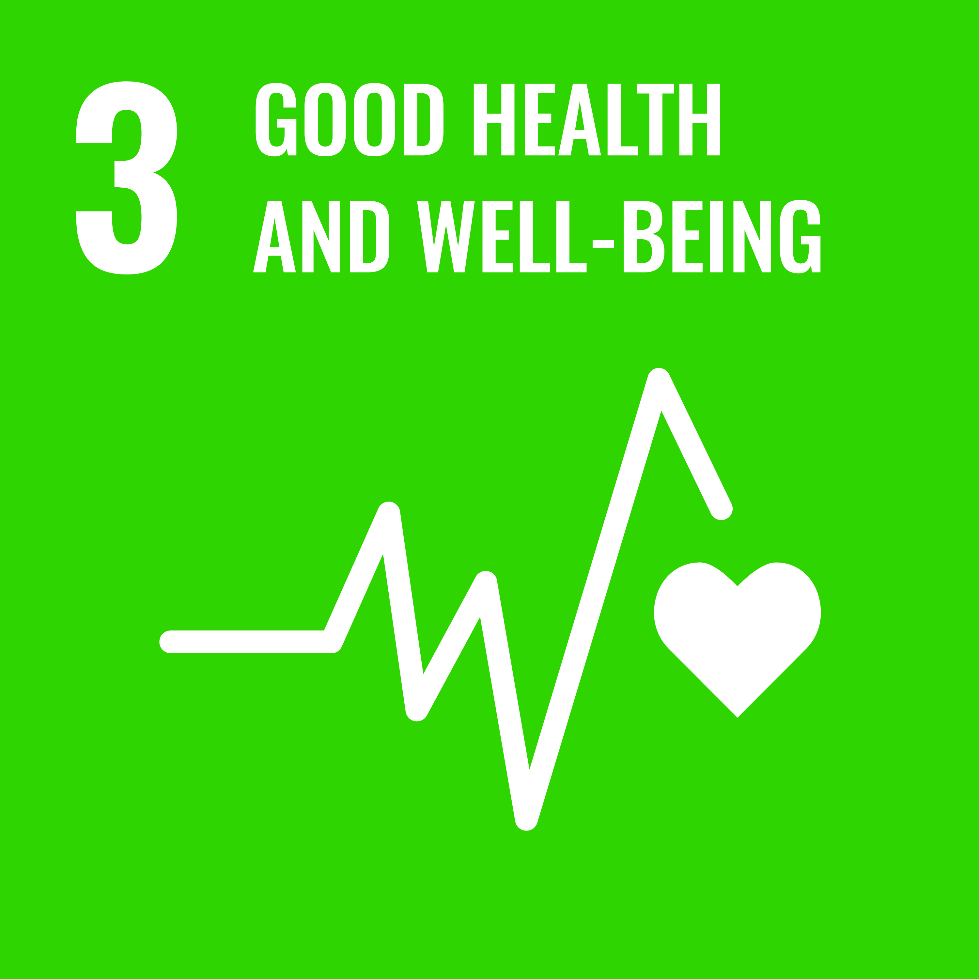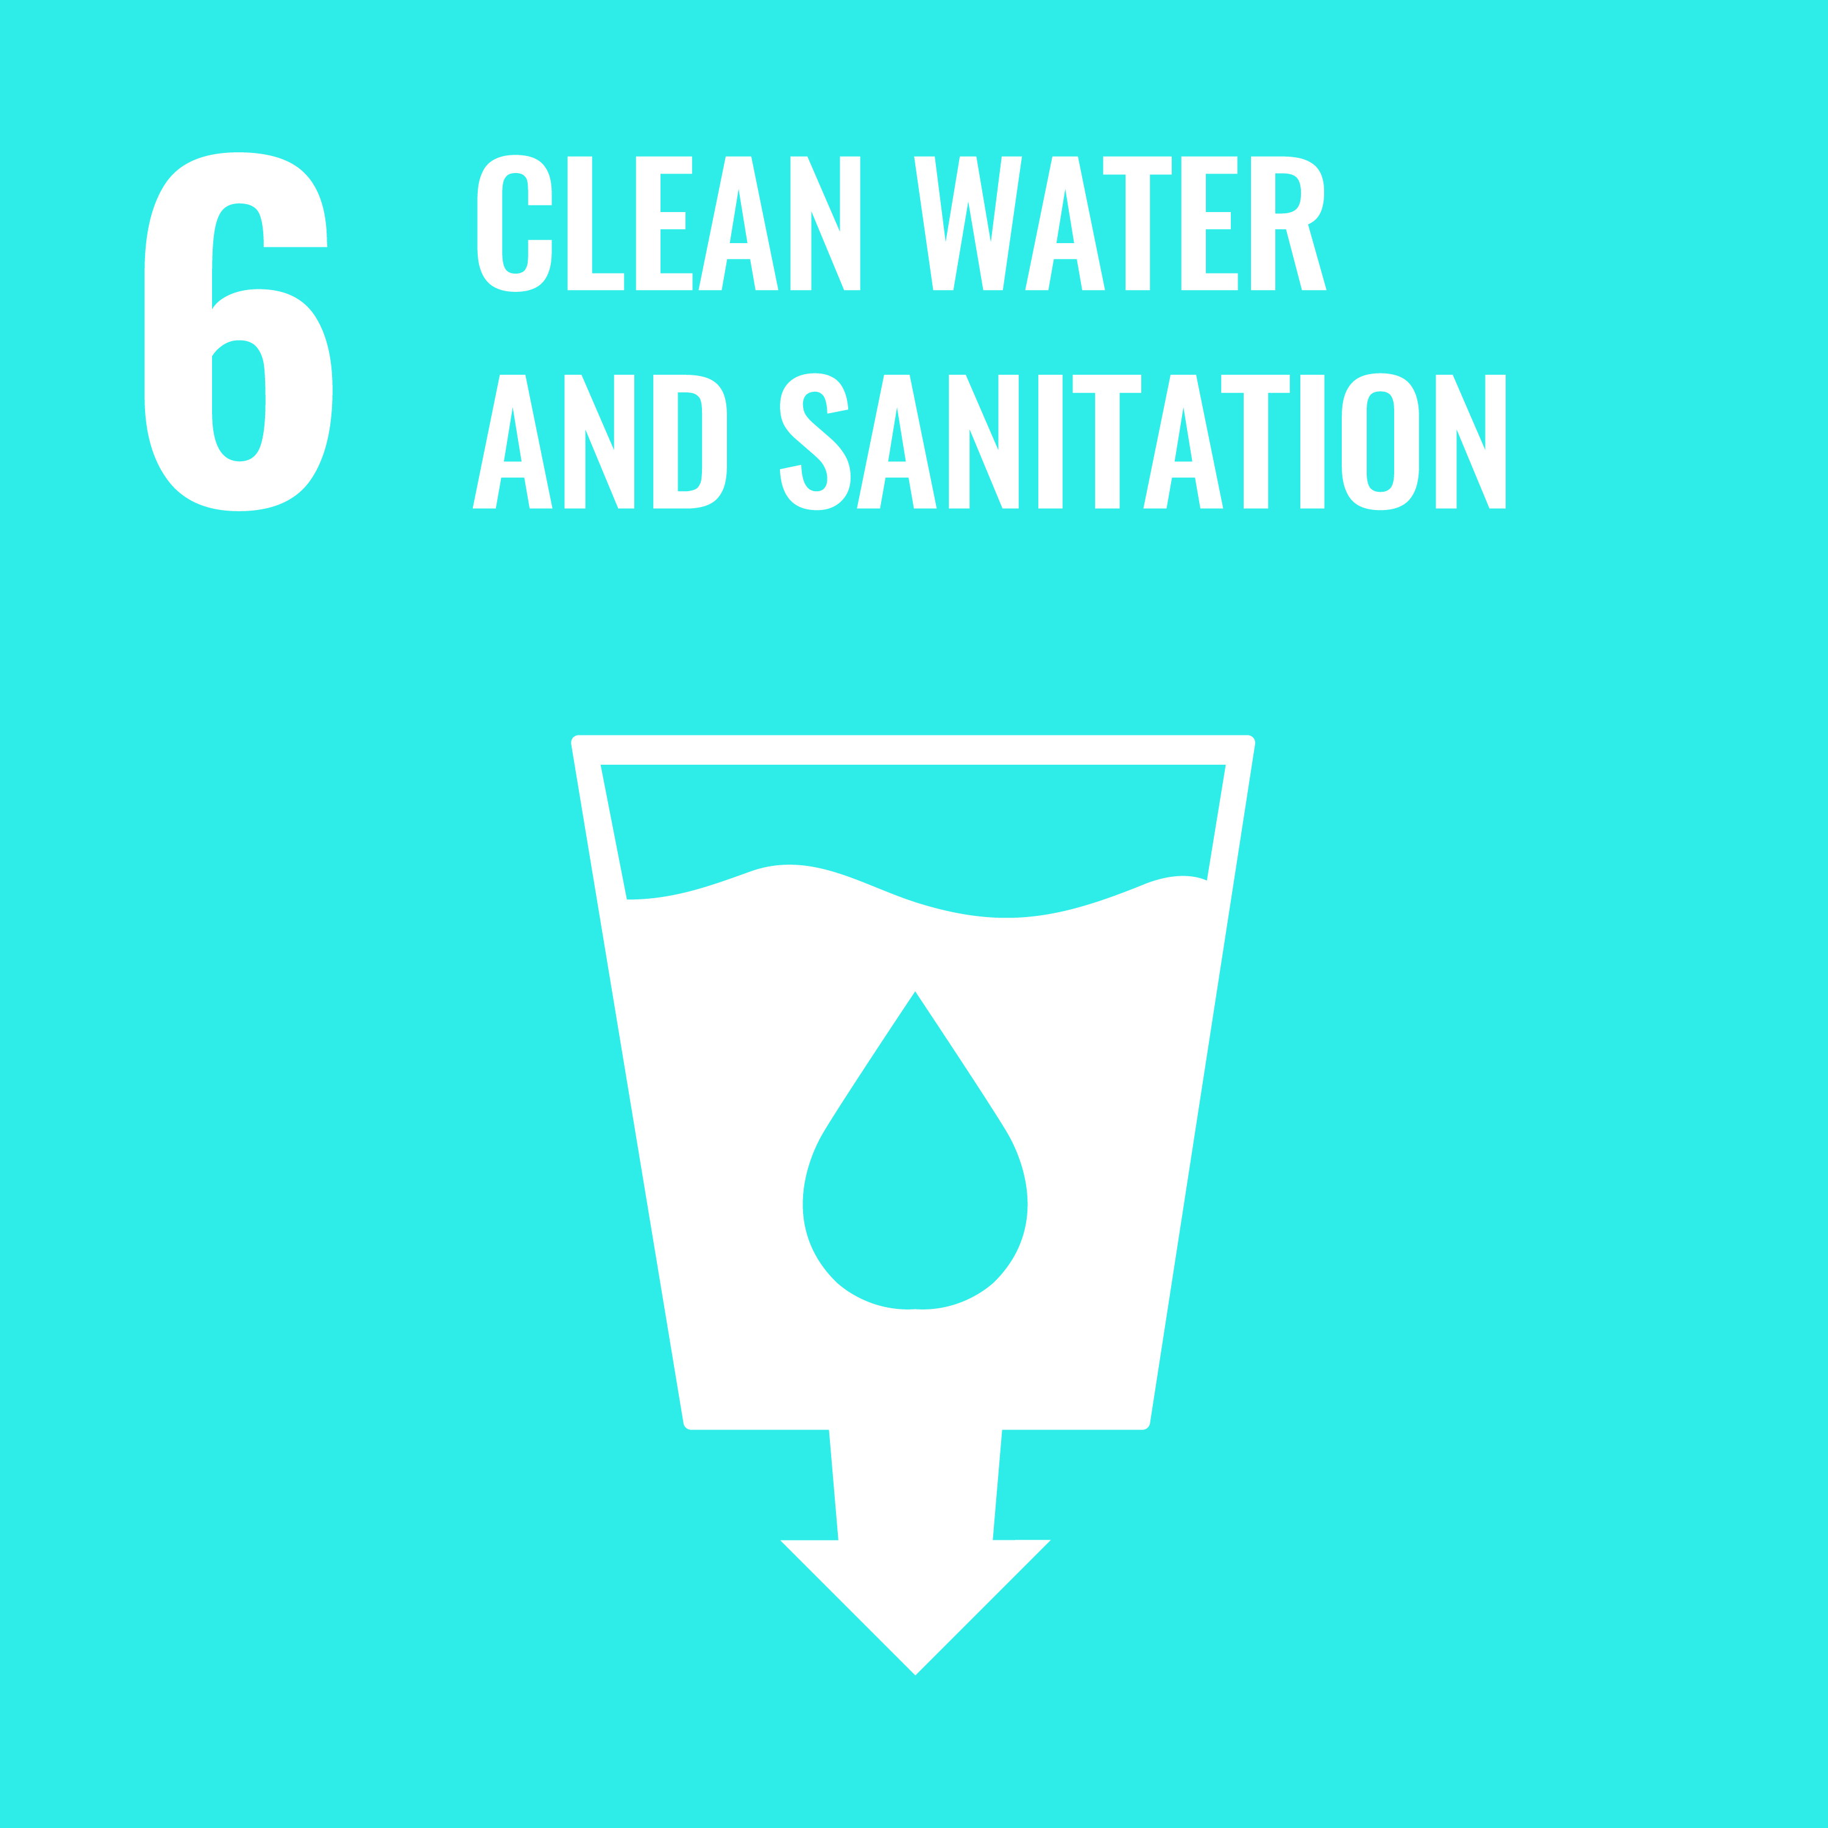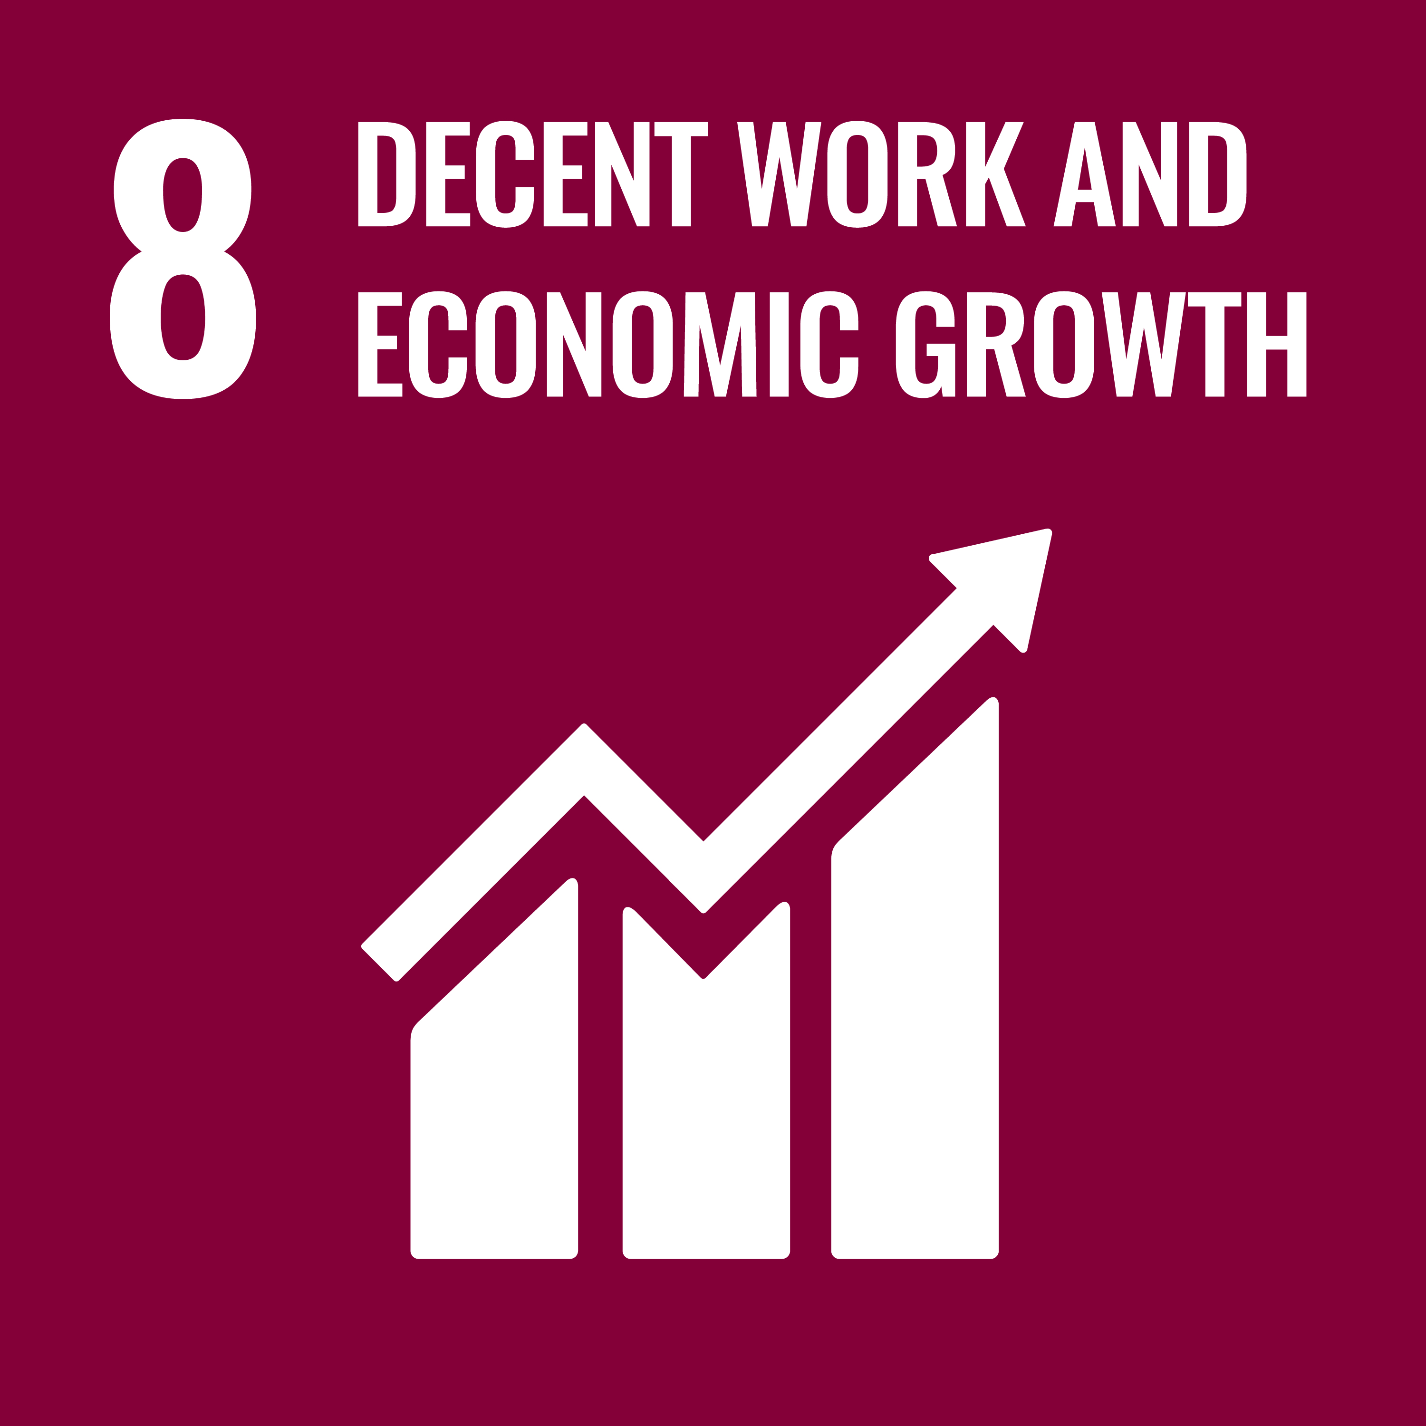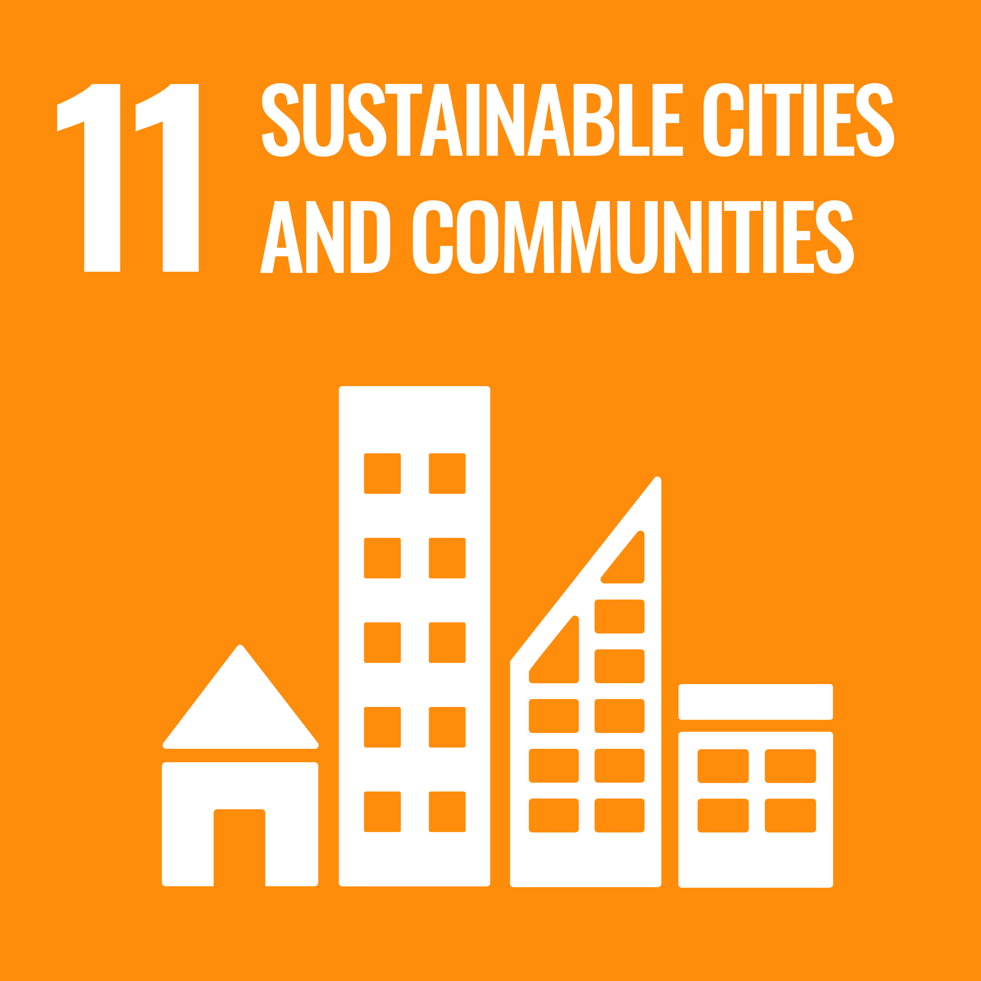

3. Good Health and Well-Being - Ensure healthy lives and promote well-being for all at all ages. https://sdgs.un.org/goals/goal3

6. Clean Water and Sanitation - Ensure availability and sustainable management of water and sanitation for all. https://sdgs.un.org/goals/goal6

8. Decent Work and Economic Growth - Promote sustained, inclusive and sustainable economic growth, full and productive employment and decent work for all. https://sdgs.un.org/goals/goal8

11. Sustainable Cities and Communities - Make cities and human settlements inclusive, safe, resilient and sustainable. https://sdgs.un.org/goals/goal11

Assessment
Formative Assessment:
Students undertake Worksheet activities to share and explore ideas by reflecting on their own context from the information from the presentation.
Students explore and record their learning via the Sustainable Neighbourhoods game. They have the opportunity to apply their learning to demonstrate their understanding.
Phase/Slide | Learning Activity |  | Resources
Slide 1 – 3  Engage | - Greetings  - Introduction  - Acknowledgement to Country  - Lesson outcomes |  | PowerPoint
Slide 4  Reflect | - UN Sustainable Development Goals Review |  | PowerPoint
Slide 5  Explore/Explain | - Transport Planning  - Sustainable Transport Hierarchy |  | PowerPoint
Slide 6 – 8  Explore/Explain | - What is active transport?  - Active transport id good for us  - Walking is great |  | PowerPoint
Slide 9  Collaborate and Communicate | - Worksheet Exercise 1 – Active Transport |  | Paper based, working in pairs
Slide 10 – 11  Explore/Explain  Elaborate | - What is public transport?  - Fun fact |  | PowerPoint
Slide 12 – 13  Explore/Explain | - Transport and getting around  - Building cities for people |  | PowerPoint
Slide 14 – 15 | - Mixed use - what is that?  - Mixed housing density |  | PowerPoint
Slide 16  Collaborate and Communicate | - Worksheet Exercise 2 – Mixed Uses |  | Paper based, working in pairs
Slide 17 - 18 | - Urban Sprawl – what is that?  - Urban fringe vs. urban infill |  | PowerPoint
Slide 19 – 21 | - What is a 20-minute city? |  | PowerPoint
Slide 22  Collaborate and Communicate | - Worksheet Exercise 3 – 20-minute city |  | Paper based, working in pairs
Slide 23  Reflecting  Communicating | - Sustainable Neighbourhoods – Lesson Review |  | PowerPoint & Game
Slide 24  Reflecting | - Sustainable Neighbourhoods – Which goals? |  | PowerPoint
Slide 25  Explain  Reflecting and Responding | - Next Week – the Challenge  - How the lessons are designed to give students the skills to complete the design challenge  - Any questions |  | PowerPoint
Slide 26 - 27  Engage | - Wrap up the lesson  - Save Game  - Equipment Packed Away  - Acknowledgement |  | PowerPoint Timer – 5 Minutes Remaining and Pack-Up time  iPads/Laptops

