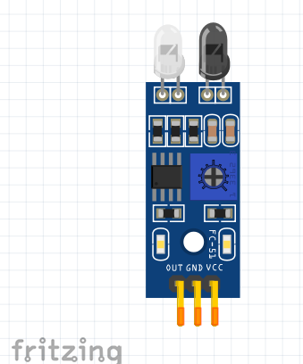
Self-Driving Car build sheet

Left infra-red sensor
Pin | Wire Colour | Connects to
OUT |  | 6
VCC |  | 7
GND |  | 8
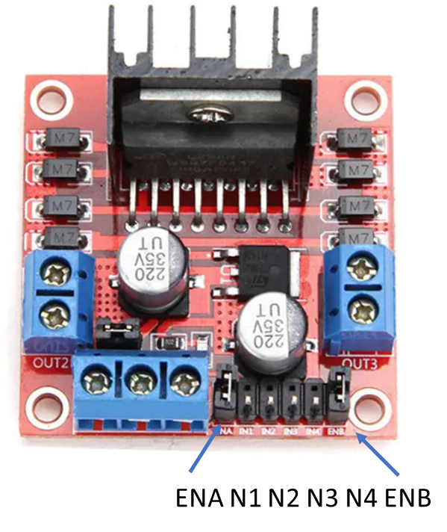

Motor drive board
Pin | Wire Colour | Connects to
ENA |  | 9
IN1 |  | 2
IN2 |  | 3
IN3 |  | 4
IN4 |  | 5
ENB |  | 10

