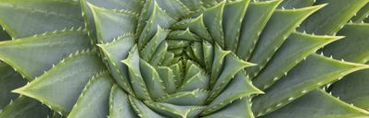

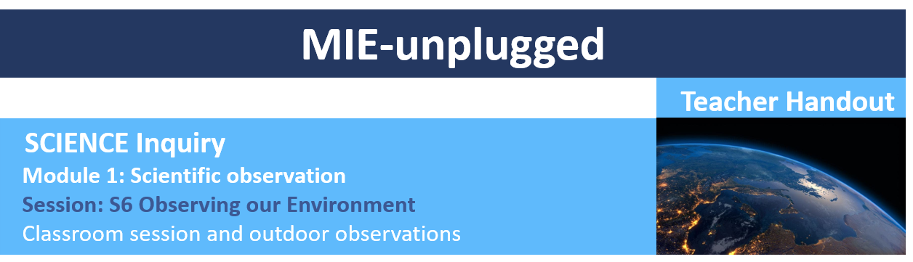

LEARNING OUTCOMES
1. Learn about circadian rhythms and how light impacts our sleep patterns. 2. Understand the negative impact of artificial lighting on bat behaviour. 3. Design and implement an experiment to measure the impact of light pollution on sleep and bat behaviour in the local area. 4. Learn how to interpret the data. 5 Understand the importance of scientific rigour in community science projects, determine sources of error and suggest improvements to scientific methodology.

SESSION OVERVIEW
This session will be carried out over the course of a week, with the first part introducing the students to negative effects of light pollution on sleep and bat behaviour. The students will then measure “darkness” and either the number of bats spotted in their back yard or their own sleep patterns throughout the week. The final part will see the students return to the classroom to analyse and interpret results across their local area. Students will then learn about the importance of scientific methodology, sources of error due to their method and ways to improve. Improvements will then be worked upon in the next module: Scientific methodology. This teacher handout is to be used alongside the data collection sheets and the PowerPoint presentation
MIE_unplugged_Observing_our_Environment.ppt provided in this module.

LEARNING STICKERS
The stickers we will acquire by the end of this session are, Evaluating, Exploring, Detecting, Designing, Simplifying and Logic. Students will pool all the skills gained over the previous sessions to plan their own experiment investigating the impacts of light pollution.

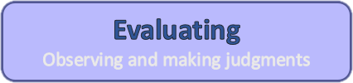
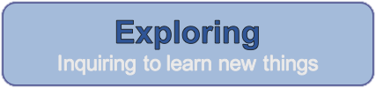
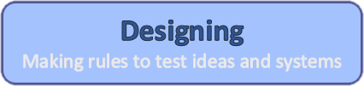
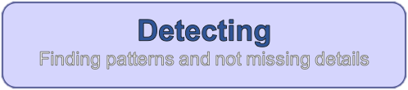
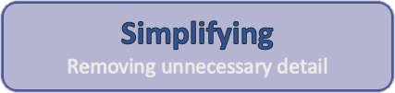
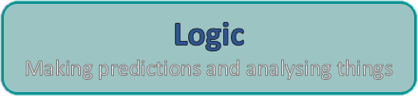

Equipment
- Data collection sheet 1 and 2
- Graph paper
- Astronomical twilight calculator. This is the time of complete darkness each night for your location. You can find this for your location here
https://www.timeanddate.com/astronomy/australia

Preparation
Introduction to task: This session will be run over a week, with the students being introduced to the task, then collecting data each night for 7 days and then analysing their data the following week. As we are investigating the impact of “darkness” of the night sky on sleep and bat behaviour, this session is best run around the new moon (±5 days). You can check the phases of the moon here https://www.timeanddate.com/moon/phases/. This session is designed to introduce students to the process of carrying out robust science so that they can build on the science observation skills they have acquired so far and learn the value of community science projects. As such, we ask the students to investigate a broad subject area, deliberately keeping it open ended. In this way, students will see how varying approaches to data collection lead to messy data that is difficult to interpret. They will need to think about what they need to observe in their environment to answer the question. They will learn that often we need to control certain variables to investigate another variable. We will then refine their skills to design scientific method in the next module: Scientific methodology.

The first 30 minutes of part 1 will be used explore in more depth the impacts of light pollution on both sleep and bat behaviour. We will then spend 20 minutes talking and encouraging the students to think about the experiment that they will have to carry out at home over the next week. In part 2 we will collate, analyse and discuss the results. Finally, we will look at some of the community science projects around light pollution in the local area.

SESSION
1. INTRODUCTION
Slides 1-9: In these slides we explore in more detail how light pollution affects our sleep, why we need darkness to sleep and the importance of a good night sleep. We will introduce the students to the two driving factors of sleep – circadian rhythm and sleep-wake homeostasis

and then ask the students to brainstorm the benefits of sleep and things that make it difficult to fall asleep in Data collection sheet 1.

Slides 10-14: Next we are going to explore in more detail the importance of bats to our ecosystem. Students will learn about the role bats play as pollinators, pest control and to our own survival. We will then cover how bat behaviour is impacted by light pollution, asking the students to brainstorm ideas around the crucial role of bats in their local area and effect of light pollution in Data collection sheet 1. When thinking about impacts to bats in the local area ask the students to think about how humans use the land around them – is there a large number of banana plantations, or avocado growers and are there large areas of new development?

Slide 15: We are now going to split the class into 2, half will investigate the impact of light pollution on their sleep patterns and half with investigate the impact of light pollution on bat behaviour. It doesn’t matter how the class is split as they will go home and collect their own data each night and then the 2 groups will pool their data to look at how change in darkness levels affects both sleep and bat measures. This will obviously work best if there is a good spread of students living in towns and countryside in each group.

2. DATA COLLECTION
Slides 16-18: Once the students know which group they are in these slides will run through the sleep pattern experiment. Here we detail what the students need to measure – darkness of their bedroom just before bedtime and sleep quality, but we deliberately let them decide how they are going to measure these two variables. Students will be asked to think about how they will measure these two things. Students should draw on the lessons from the previous Dark skies session, where they had to measure darkness of the night sky. And, depending on your year group you may wish to prompt them to start to think about sleep quality measures (duration, how rested they felt from 1-10 upon waking etc.). They should they write down their individual method on Data Collect Sheet 2. Encourage students to think of their own measure and not just all do the same. This is important as later we will see how there are many ways to investigate a problem and robust science needs to look at all aspects to clearly define measures and variables. In the next module: Scientific methodology we will build on their individual ideas to measure sleep quality to build a robust procedure to do so.

Slides 19-21: We will now do the same for the bat behaviour experimental group. Once again, the students will be told what the need to measure but not how. Encourage students to think about how they will count bats and again get them to write down their individual method on Data Collection Sheet 2. This may be how many they spotted in an hour, or how many fed in

the fruit trees around their house before they went to bed etc. Again, in the next module we will build on their individual ideas to build a robust procedure to do so.

Slides 22-25: Now we are going to bring all the data together and plot it on the graph paper. Before we do this get them to hypothesize what they expect to see. Next, follow the slides to show the students how to set out their graph (one for each team) and how to plot their 7 data points (one for each night). By the end there should be 2 graphs, one for the sleep group and one for the bat group, with all the data from each student in each team.

Slides 26-29: Next get the students to draw a trend line through the data. This doesn’t have to be the exact mathematical line of best fit, just a line that best fits their data points. It may well be that there is no correlation. In fact, at this stage we are expecting that the graphs wont really show a trend. This is because we haven’t standardized their method of data collection! Now ask them to think about what their trend line tells us about the relationship between light pollution and sleep quality and bat behaviour? Discuss this with the class and ask them if this matches their hypothesis, is this what they were expecting?

Slide 30: Now we are going to get the students to think about sources of error and potential improvements to their observations and measures. Spend some time on this, asking each question in turn as we will revisit this in the next module.

Slides 31-33: These slides wrap up this module, showing the students that by carrying out this Science Observation Module you have learnt to explore your environment, evaluate your observations to detect patterns and then design and simplify experiments to investigate further! You have then used all these skills together to use logic to make predictions and analysis your observations! This is a great start! We now have the fundamental skills to perform any scientific observation

Slide 34: The impact of human activity on wildlife has been observed and known about for a long time. Science is embedded in Aboriginal and Torres Strait Islander culture and it would be extremely valuable to hear about what their culture can teach us about how human activity has impacted the local wildlife in their area.

Year 6 – Observing our Environment
Lesson number | Focus | Australian Curriculum and General Capabilities | Australian Curriculum Content Descriptors
S06 | Observing our environment | - Personal and Social Capability –  Making decisions  - Critical and Creative Thinking –  Identify and clarify information and ideas  - Critical and Creative Thinking –  Evaluate procedures and outcomes  - Critical and Creative Thinking –  Seek solutions, possibilities and actions  - Critical and Creative Thinking –  Consider alternatives  - Word knowledge–  Understand learning area vocabulary | Science – Science understanding: The growth and survival of living things are affected by physical conditions of their environment (ACSSU094 - Scootle )  Science – Science as a human endeavour: Use and Influence of science- Scientific knowledge is used to solve problems and inform personal and community decisions (ACSHE100 - Scootle )  Science – Science inquiry skills: With guidance, pose clarifying questions and make predictions about scientific investigations (ACSIS232 - Scootle )  Science – Science inquiry skills: Identify, plan and apply the elements of scientific investigations to answer questions and solve problems using equipment and materials safely and identifying potential risks (ACSIS103 - Scootle )  Science – Science inquiry skills: Reflect on and suggest improvements to scientific investigations (ACSIS108 - Scootle )  Science – Science inquiry skills: Communicate ideas, explanations and processes using scientific representation in a variety of ways. (ACSIS110 - Scootle )  Science - learn to appreciate the contribution that diverse cultural perspectives have made to the development, breadth and diversity of science knowledge and applications (ACSHE098 - Scootle )
 | Focus | Learning outcomes | Resources
 | Observing our environment | - Learn about circadian rhythms and how light impacts our sleep patterns.  - Understand the negative impact of artificial lighting on bat behaviour.  - Design and implement an experiment to measure the impact of light pollution on sleep and bat behaviour in the local area.  - Learn how to interpret the data.  - Understand the importance of scientific rigour in community science projects, determine sources of error and suggest improvements to scientific methodology. | Science Inquiry Module 1: Session 6 - Teacher handout  MIE_unplugged_Observing_our_Environment.ppt  Data collection sheet word document  Graph paper

Year 7 – Observing our Environment
Lesson number | Focus | Australian Curriculum and General Capabilities | Australian Curriculum Content Descriptors
S06 | Observing our environment | - Personal and Social Capability –  Working collaboratively  - Personal and Social Capability –  Work independently and show initiative  - Critical and Creative Thinking –  Identify and clarify information and ideas  - Critical and Creative Thinking –  seek solutions and put ideas into action  - Critical and Creative Thinking –  Draw conclusions and design a course of action  - Critical and Creative Thinking –  Evaluate procedures and outcomes  - Critical and Creative Thinking –  Reflect on processes  - Critical and Creative Thinking –  Organise and process information  - Ethical understanding –  Exploring values, rights and responsibilities  - Word knowledge–  Understand learning area vocabulary | Science – Science as a human endeavor: Science knowledge can develop through collaboration across the disciplines of science and the contributions of people from a range of cultures (ACSHE223 - Scootle )  Science - Science as a human endeavor: use and influence: People use science understanding and skills in their occupations and these have influenced the development of practices in areas of human activity (ACSHE121 - Scootle )  Science – Science inquiry skills: Identify questions and problems that can be investigated scientifically and make predictions based on scientific knowledge (ACSIS124 - Scootle )  Science – Science inquiry skills: Collaboratively and individually plan and conduct a range of investigation types, including fieldwork and experiments, ensuring safety and ethical guidelines are followed (ACSIS125 - Scootle )  Science – Science inquiry skills: Summarise data, from students’ own investigations and secondary sources, and use scientific understanding to identify relationships and draw conclusions based on evidence (ACSIS130 - Scootle )  Science – Science inquiry skills: Reflect on scientific investigations including evaluating the quality of the data collected, and identifying improvements (ACSIS131 - Scootle )
 | Focus | Learning outcomes | Resources
 | Observing our environment | - Learn about circadian rhythms and how light impacts our sleep patterns.  - Understand the negative impact of artificial lighting on bat behaviour.  - Design and implement an experiment to measure the impact of light pollution on sleep and bat behaviour in the local area.  - Learn how to interpret the data.  - Understand the importance of scientific rigour in community science projects, determine sources of error and suggest improvements to scientific methodology. | Science Inquiry Module 1: Session 6 - Teacher handout  MIE_unplugged_Observing_our_Environment.ppt  Data collection sheet word document  Graph paper

Year 8 – Observing our Environment
Lesson number | Focus | Australian Curriculum and General Capabilities | Australian Curriculum Content Descriptors
S06 | Observing our environment | - Numeracy –  Recognise and use patterns and relationships  - Personal and Social Capability –  Working collaboratively  - Personal and Social Capability –  Work independently and show initiative  - Critical and Creative Thinking –  Identify and clarify information and ideas  - Critical and Creative Thinking –  seek solutions and put ideas into action  - Critical and Creative Thinking –  Reflect on processes  - Critical and Creative Thinking –  Organise and process information  - Critical and Creative Thinking –  Draw conclusions and design a course of action  - Word knowledge–  Understand learning area vocabulary | Science - Science as a human endeavor: Science knowledge can develop through collaboration across the disciplines of science and the contributions of people from a range of cultures (ACSHE226 - Scootle )  Science - Science as a human endeavor: People use science understanding and skills in their occupations and these have influenced the development of practices in areas of human activity (ACSHE136 - Scootle )  Science – Science inquiry skills: Identify questions and problems that can be investigated scientifically and make predictions based on scientific knowledge (ACSIS139 - Scootle )  Science – Science inquiry skills: Collaboratively and individually plan and conduct a range of investigation types, including fieldwork and experiments, ensuring safety and ethical guidelines are followed (ACSIS140 - Scootle )  Science – Science inquiry skills: Construct and use a range of representations, including graphs, keys and models to represent and analyse patterns or relationships in data (ACSIS144 - Scootle )  Science – Science inquiry skills: Summarise data, from students’ own investigations and secondary sources, and use scientific understanding to identify relationships and draw conclusions based on evidence (ACSIS145 - Scootle )  Science – Science inquiry skills: Communicate ideas, findings and evidence based solutions to problems using scientific language, and representations (ACSIS148 - Scootle )  Science – Science inquiry skills: Reflect on scientific investigations including evaluating the quality of the data collected, and identifying improvements (ACSIS146 - Scootle )
 | Focus | Learning outcomes | Resources
 | Observing our environment | - Learn about circadian rhythms and how light impacts our sleep patterns.  - Understand the negative impact of artificial lighting on bat behaviour.  - Design and implement an experiment to measure the impact of light pollution on sleep and bat behaviour in the local area.  - Learn how to interpret the data.  - Understand the importance of scientific rigour in community science projects, determine sources of error and suggest improvements to scientific methodology. | Science Inquiry Module 1: Session 6 - Teacher handout  MIE_unplugged_Observing_our_Environment.ppt  Data collection sheet word document  Graph paper

