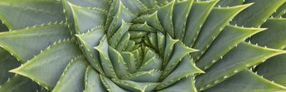

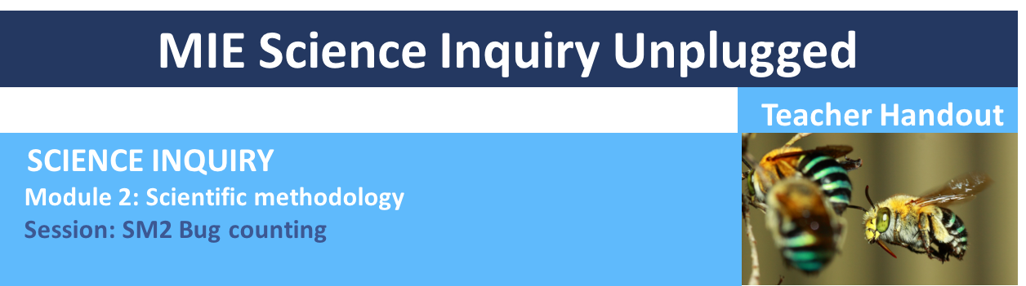

LEARNING OUTCOMES
1. Understand how all scientists carry out research and learn about scientific approach that underpins all scientific experiments. 2. Learn how to design an experiment to study insect biodiversity and 3. Learn how to sample and survey the insect life around their school using strategic and random sampling techniques.

SESSION OVERVIEW
In this session students will learn about how to design an experiment to test their hypothesis that they generated in session 1. Students will learn how to make and use quadrats, a scientific method to sample flora and fauna, and start to collect strategic and random data samples around their school. The key concepts they are going to touch on are scientific methodology, data sampling, insect biodiversity and insect identification. This teacher handout is to be used alongside the Data Collection Sheet 2 and the PowerPoint presentation provided in this module.
MIE_Science_Inquiry_unplugged_SM2_Bug_Counting.ppt

LEARNING ATTRIBUTES
The attributes we will acquire by the end of this session are Logic, Creating and Experimenting.

By posing a question and then carefully and accurately sampling the insects around our school we can start to calculate and study our environment.

Equipment
- Data collection Sheet 2
- String, wire, pegs, plastic piping – equipment to make quadrats
- Pen/pencil
- Tape measures for strategic sampling groups
- Sunscreen and hat
- Bottle of water

Preparation

Introduction to task: This session is broken down into 20-minute introduction to the task, 30-minute build and a 20-minute data collection.

Data collect sheet: Students may need more pages to note down all the insects that they see so you can print off more than one page. If they don’t know the name of the insect encourage them to describe it or draw it.

Map of the school: before the lesson you will need to prepare a map of the school. Either on a large piece of paper big enough for all the students to mark where they will survey insects, or you could project a google map image onto a smart board (if you have one) and then write on this. We prefer the paper and pen method as it encourages students to get up and mark their data. You can also easily bring it out for the next session as a comparison.

Supplies to make the quadrats: before this session begins gather supplies to make simple quadrats outlined in this session (1 per pair of students). This could be string and pegs, cardboard, wire or plastic piping. Details on how to make quadrats are given in the ppt.

Survey location: In this session we are going to go outside and survey bugs in the school ground. Pick a suitable spot so that the students can spread out and survey different areas safely. A playing field is good for this.

SESSION
1. INTRODUCTION
In the first 20 minutes of this session we are going to run through the first 12 slides of the PowerPoint presentation.

Slides 1-3: These slides provide help and information about the USC STEM team, our contact details, mission statements and copyright policies.

Slide 4: This slide details the aims for today and the attributes that we will be collecting upon completion of this session.

Slide 5: These slides explain what we are going to achieve in this session and recap the last one. Here we go through the fourth step of the scientific approach – designing an experiment.

Slide 6: We are next going to walk the class through some questions about how accurate and scientific our approach was in the last session. Ask the class to think about how all the pairs collected data. They will find that everyone had a slightly different approach and that it is therefore hard to compare or draw conclusions from results.

Slides 7-10: These slides explain how we can use quadrats to survey insects and plants and the idea of strategic and random sampling to start to ask questions about our environment.

Slides 11-12: Here we introduce the build task – in their pairs, students will make their own quadrats to the specs on the slide. The video runs through some ideas that they can use to create their squares. Here you will need the string, pegs, wire etc. that is stated in the equipment list.

2. BUILDING THE QUADRATS
We will now take 30 minutes to build the quadrats. Make sure that each pair labels their quadrat as they will use them in the next session. Once they have made their quadrats divide the pairs into 2 groups, the random and strategic sampling groups.

Slides 13-14: These slides run through the random sampling technique. First the students will need to pick a location around the school to randomly sample (a school playing field is a good start) and then we run through how to fill out the Data Collection Sheets 2.

Slides 16-18: These slides run through the strategic sampling technique. First the students will need to pick a site of high human activity to sample around their school and then we run through how to fill out the Data Collection Sheets 2. These pairs will need to decide how far away each pair will sample from the site.

3. DATA ANALYSIS
Slide 19: Once the students are comfortable with the Data Collection Sheets and what they need to do take them outside to survey the bug life. In their pairs they will need to then write down all the bugs they can see in their quadrat. Finally get the pairs to hand in their sheets as we will be referring back to them throughout the module.

Slide 20: Insect biodiversity is important for humanity’s survival from farming to a direct source of food. It would be extremely valuable to hear from a member of the local community about how your human activity in your area impacts insect biodiversity.

Year 7 – Bug counting
Lesson number | Focus | Australian Curriculum and General Capabilities | Australian Curriculum Content Descriptors
SM2 | Bug counting | - Numeracy –  Recognise and use patterns and relationships  - Personal and Social Capability –  Working collaboratively  - Critical and Creative Thinking –  Identify and clarify information and ideas  - Critical and Creative Thinking –  seek solutions and put ideas into action  - Critical and Creative Thinking –  Apply logic and reasoning  - Critical and Creative Thinking –  Evaluate procedures and outcomes  - Critical and Creative Thinking –  Reflect on processes  - Critical and Creative Thinking –  Organise and process information | Science – Science inquiry skills: Identify questions and problems that can be investigated scientifically and make predictions based on scientific knowledge (ACSIS124 - Scootle )  Science – Science inquiry skills: Collaboratively and individually plan and conduct a range of investigation types, including fieldwork and experiments, ensuring safety and ethical guidelines are followed (ACSIS125 - Scootle )  Science – Science inquiry skills: Measure and control variables, select equipment appropriate to the task and collect data with accuracy (ACSIS126 - Scootle )  Science – Science inquiry skills: Summarise data, from students’ own investigations and secondary sources, and use scientific understanding to identify relationships and draw conclusions based on evidence (ACSIS130 - Scootle )  Science – Science inquiry skills: Reflect on scientific investigations including evaluating the quality of the data collected, and identifying improvements (ACSIS131 - Scootle )
 | Focus | Learning outcomes | Resources
 | Bug counting | - Understand how we can observe our surroundings to learn about and measure our natural environment to solve very big problems.  - Learn how to carry out scientific method.  - Learn how to design an experiment to test a hypothesis.  - Learn to sample insect biodiversity around school, compare measurements with fellow students, discuss sources of error and error margins.  - Learn how to make and use the scientific survey tool, the quadrat | Science Inquiry Module 2: Practical 2 - Teacher handout  MIE_Science_Inquiry_unplugged_Bug_Counting.ppt  Data collection sheet word document  Experimental equipment listed above

Year 8 – Bug counting
Lesson number | Focus | Australian Curriculum and General Capabilities | Australian Curriculum Content Descriptors
SM2 | Bug counting | - Numeracy –  Recognise and use patterns and relationships  - Personal and Social Capability –  Working collaboratively  - Critical and Creative Thinking –  Identify and clarify information and ideas  - Critical and Creative Thinking –  seek solutions and put ideas into action  - Critical and Creative Thinking –  Apply logic and reasoning  - Critical and Creative Thinking –  Evaluate procedures and outcomes  - Critical and Creative Thinking –  Reflect on processes  - Critical and Creative Thinking –  Organise and process information | Science – Science inquiry skills: Identify questions and problems that can be investigated scientifically and make predictions based on scientific knowledge (ACSIS139 - Scootle )  Science – Science inquiry skills: Collaboratively and individually plan and conduct a range of investigation types, including fieldwork and experiments, ensuring safety and ethical guidelines are followed (ACSIS140 - Scootle )  Science – Science inquiry skills: Measure and control variables, select equipment appropriate to the task and collect data with accuracy (ACSIS141 - Scootle )  Science – Science inquiry skills: Summarise data, from students’ own investigations and secondary sources, and use scientific understanding to identify relationships and draw conclusions based on evidence (ACSIS145 - Scootle )  Science – Science inquiry skills: Reflect on scientific investigations including evaluating the quality of the data collected, and identifying improvements (ACSIS146 - Scootle )
 | Focus | Learning outcomes | Resources
 | Bug counting | - Understand how we can observe our surroundings to learn about and measure our natural environment to solve very big problems.  - Learn how to carry out scientific method.  - Learn how to design an experiment to test a hypothesis.  - Learn to sample insect biodiversity around school, compare measurements with fellow students, discuss sources of error and error margins.  - Learn how to make and use the scientific survey tool, the quadrat | Science Inquiry Module 2: Practical 2 - Teacher handout  MIE_Science_Inquiry_unplugged_Bug_Counting.ppt  Data collection sheet word document  Experimental equipment listed above

