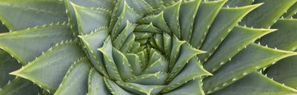

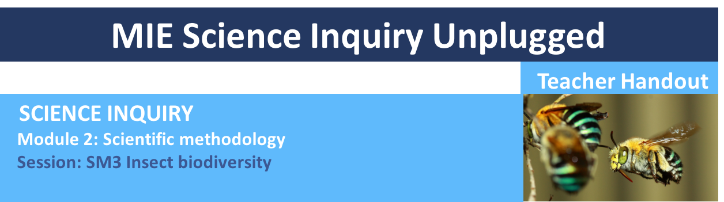

LEARNING OUTCOMES
1. Understand how all scientists carry out research and learn about scientific approach that underpins all scientific experiments. 2. Learn how to analyse and draw conclusions from collected data and 3. Learn how to critically evaluate and develop and expand the experimental design to improve the robustness of data collected.

SESSION OVERVIEW
In this session students will collate and analyse the data collected in session 2. From this they will evaluate their experimental design and improve upon it, learning how to make and use another common surveying method, the ground and hanging trap. Students will then sample the insect population around school using these traps to add to their data sample. The key concepts they are going to touch on are scientific methodology, data sampling, insect biodiversity and insect identification. This teacher handout is to be used alongside the Data Collection Sheet 2 and 3 and the PowerPoint presentation provided in this module.
MIE_Science_Inquiry_unplugged_SM3_Insect_Biodiversity.ppt

LEARNING ATTRIBUTES
The attributes we will acquire by the end of this session are Creating, Experimenting and Preserving.

By posing a question and then carefully and accurately sampling the insects around our school we can start to calculate and study our environment.

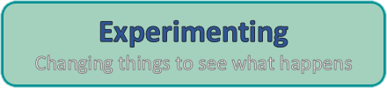

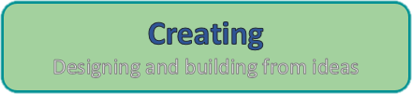

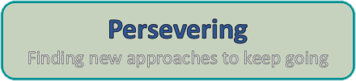

Equipment
- Data collection Sheet 2 and 3 and insect identification sheet
- Map of the school
- String, wire, plastic bottles, yogurt pots – equipment to make traps
- Pen/pencil
- Tape measures for strategic sampling groups
- Sunscreen and hat and bottle of water

Preparation

Introduction to task: This session is split into a 25-minute introduction to the task, followed by a 30-minute build and 15 minute laying of traps. There will then be break to allow enough time for insects to enter the traps and then a 30-minute data collection period. It is up to you how you organize this session. Depending on your class it could be carried out over 2 days.

Data collect sheet: Students may need more pages to note down all the insects that they see so you can print off more than one page. If they don’t know the name of the insect encourage them to describe it or draw it.

Maps of the school: before the session you will need to prepare two maps of the school. One needs to be labelled random sample data and the other strategic sample data. Either on a large piece of paper big enough for all the students to mark where they will survey insects or you could project a google map image onto a smart board (if you have one) and then write on this. We prefer the paper and pen method as it encourages students to get up and mark their data. You can also easily bring it out for the next session as a comparison.

Supplies to make ground and hanging traps: before this session you will need to ask the students to bring in any large (1-2lt) plastic bottles, large yogurt pots or tin cans that they have at home. This is to make the traps outlined in this session. You will need enough for 1 trap per pair of students. Details on how to make the traps are given in the ppt. you will also need a small piece of fruit to place in each trap to attract the insects. The traps are humane and insects will be released after being recorded.

Survey location: In this session we are going to go outside and survey bugs in the school ground. Pick a suitable spot so that the students can spread out and survey different areas

safely. Students will need to dig a small hole for the ground traps so pick somewhere where this is appropriate to do this. Flower beds and grass boarders maybe suitable for this.

SESSION
1. COLLATING AND ANALYSING DATA
In the first 25 minutes of this session we are going to run through the first 8 slides of the PowerPoint presentation.

Slides 1-3: These slides provide help and information about the USC STEM team, our contact details, mission statements and copyright policies.

Slide 4: This slide details the aims for today and the attributes that we will be collecting upon completion of this session.

Slides 5-6: These slides provide a recap of the last session and explain the next steps of the scientific method that we will carryout in this session – analysing results and modifying experimental design.

Slide 7: We are now going to collate all the data from the last session so we will need to get out Data Collection Sheet 2. Get out the map of the school grounds (paper or board projection) and ask the students in their pairs to come up and mark their location along with their data – total number of insects surveyed and total number of different types. It may also be helpful at this stage to refer back to the insect identification sheet that they created in session 1. It maybe easier to use one map for the random sampling data and one for the strategic sampling data groups. If you are using two maps label them either random or strategic sample data map as we will then use these maps in the next session. If you are using one map then the data points will need to be labelled as random sample or strategic sample data points on the map.

Slide 8: Now we will interpret our results. Ask the students to look at the total number and number of different types of insects at each site that they have surveyed. Are they roughly the same at each site? If not, why not? Are there any patterns? Are there more insects but less types closer to school buildings where humans would normally gather? Discuss your data and possible reasons why you see these patterns and refer back to their hypothesis. This slide is designed to get the students thinking about whether they have collected enough data to prove/disprove their hypothesis.

2. BUILDING THE GROUND AND HANGING TRAPS
We will now take 45 minutes to build the traps, prepare our data collection sheet and then lay the traps. Make sure that each pair labels their traps as they will use them in the next session. Once they have made their traps divide the pairs into 2 groups, the random and strategic sampling groups.

Slide 9: Here we will run through the advantages and disadvantages of using quadrats and introduce the survey method of traps. Students will see that we can survey slow ground dwelling insects but a lot of the flying or faster insects were not counted.

Slides 10-13: These slides run through simple ground and hanging trap designs that the students will then make and later lay. They are designed not to harm the insects and are transparent so you can see any potential harmful insects that are caught inside that will need to be released with care by an adult. In the pairs the students will need to pick a ground or hanging trap to make (a 50/50 split is ideal) and then spend about 15 minutes making them.

Sides 14-18: We will now run through how to lay the traps. Then the students will need to pick a location around the school to randomly and strategically sample again. It’s a good idea to pick different random sample sites and you may not be able to place the traps at exactly the same strategic sample sites. This is fine as long as they are strategically placed. We will next run through how to fill out the Data Collection Sheets 3.

Slide 19: Now we are ready to go outside and lay our traps. This will take about 15 minutes. We will have to wait at least an hour to then come back to record and then release any insect caught inside.

--------------------------------------------------- BREAK ------------------------------------------------------------

3. DATA RECORDING
Slides 20-23: After the break it is now time to revisit the traps and record the insects inside. These slide run through how to inspect the traps before opening, how to record the insects in the traps and how to release the insects safely. Once the students are comfortable with this it is time to go outside and revisit the traps. This should take around 30 minutes.

Slide 24: Many people around the world rely on insects as a source of food. Although a healthy insect population is vital for the planet’s survival, eating insects for a source of protein is more environmentally friendly than eating meat. It would be extremely valuable to hear from a member of the local community about how we can trap insects to eat and the nutrition they provide.

Year 7 – Insect biodiversity
Lesson number | Focus | Australian Curriculum and General Capabilities | Australian Curriculum Content Descriptors
SM3 | Insect biodiversity | - Numeracy –  Recognise and use patterns and relationships  - Personal and Social Capability –  Working collaboratively  - Critical and Creative Thinking –  Identify and clarify information and ideas  - Critical and Creative Thinking –  seek solutions and put ideas into action  - Critical and Creative Thinking –  Apply logic and reasoning  - Critical and Creative Thinking –  Evaluate procedures and outcomes  - Critical and Creative Thinking –  Reflect on processes  - Critical and Creative Thinking –  Organise and process information | Science – Science inquiry skills: Identify questions and problems that can be investigated scientifically and make predictions based on scientific knowledge (ACSIS124 - Scootle )  Science – Science inquiry skills: Collaboratively and individually plan and conduct a range of investigation types, including fieldwork and experiments, ensuring safety and ethical guidelines are followed (ACSIS125 - Scootle )  Science – Science inquiry skills: Measure and control variables, select equipment appropriate to the task and collect data with accuracy (ACSIS126 - Scootle )  Science – Science inquiry skills: Summarise data, from students’ own investigations and secondary sources, and use scientific understanding to identify relationships and draw conclusions based on evidence (ACSIS130 - Scootle )  Science – Science inquiry skills: Reflect on scientific investigations including evaluating the quality of the data collected, and identifying improvements (ACSIS131 - Scootle )
 | Focus | Learning outcomes | Resources
 | Insect biodiversity | - Understand how we can observe our surroundings to learn about and measure our natural environment to solve very big problems.  - Learn how to carry out scientific method, analysing data to prove/disprove hypotheses.  - Learn how critique and then improve on experimental design to strengthen results.  - Learn to sample insect biodiversity around school, compare measurements with fellow students, discuss sources of error and error margins.  - Learn how to make and use the scientific survey tool, the ground and hanging trap. | Science Inquiry Module 2: Practical 3 - Teacher handout  MIE_Science_Inquiry_unplugged_Insect_Biodiversity.ppt  Data collection sheet word document  Experimental equipment listed above

Year 8 – Insect biodiversity
Lesson number | Focus | Australian Curriculum and General Capabilities | Australian Curriculum Content Descriptors
SM3 | Insect biodiversity | - Numeracy –  Recognise and use patterns and relationships  - Personal and Social Capability –  Working collaboratively  - Critical and Creative Thinking –  Identify and clarify information and ideas  - Critical and Creative Thinking –  seek solutions and put ideas into action  - Critical and Creative Thinking –  Apply logic and reasoning  - Critical and Creative Thinking –  Evaluate procedures and outcomes  - Critical and Creative Thinking –  Reflect on processes  - Critical and Creative Thinking –  Organise and process information | Science – Science inquiry skills: Identify questions and problems that can be investigated scientifically and make predictions based on scientific knowledge (ACSIS139 - Scootle )  Science – Science inquiry skills: Collaboratively and individually plan and conduct a range of investigation types, including fieldwork and experiments, ensuring safety and ethical guidelines are followed (ACSIS140 - Scootle )  Science – Science inquiry skills: Measure and control variables, select equipment appropriate to the task and collect data with accuracy (ACSIS141 - Scootle )  Science – Science inquiry skills: Summarise data, from students’ own investigations and secondary sources, and use scientific understanding to identify relationships and draw conclusions based on evidence (ACSIS145 - Scootle )  Science – Science inquiry skills: Reflect on scientific investigations including evaluating the quality of the data collected, and identifying improvements (ACSIS146 - Scootle )
 | Focus | Learning outcomes | Resources
 | Insect biodiversity | - Understand how we can observe our surroundings to learn about and measure our natural environment to solve very big problems.  - Learn how to carry out scientific method, analysing data to prove/disprove hypotheses.  - Learn how critique and then improve on experimental design to strengthen results.  - Learn to sample insect biodiversity around school, compare measurements with fellow students, discuss sources of error and error margins.  - Learn how to make and use the scientific survey tool, the ground and hanging trap. | Science Inquiry Module 2: Practical 3 - Teacher handout  MIE_Science_Inquiry_unplugged_Insect_Biodiversity.ppt  Data collection sheet word document  Experimental equipment listed above

