MIE Brain Lesson 4

Build resilience into our network
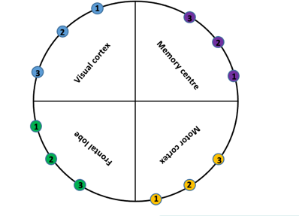
We are now going to put what we have learnt about learning, the impacts of stress and resilience into practice and build our own brain network to learn a new skill even when we are under stress.

All students come towards the front of the class.
Part 1
I need 16 volunteers to stand in a circle to join in an activity. Students stand in a circle, everyone takes a step back. (Adapt and use what space you have available).
Give students a coloured NUMBER card. (Important to keep the order as it represents the Brain Board cortices).
Starting with: Blue numbers - 1- 4
Green numbers - 1- 4
Yellow numbers - 1- 4
Purple numbers - 1- 4
Message cards describe a new skill or task.
Blue Card = message 1 (Names the new task)
Red Card = message 2 (Provides how to learn or complete the new task)
- Give person 1 (Blue number 1) the Blue message card.
- This person silently reads the BLUE and message cards SILENTLY.
- Give person 4 (Blue number 4) the Red message card to read SILENTLY.

The Red Message - can only be passed to every 2nd person: numbers 1 & 3 holding each colour card.

We are going to start with our Random network the 2nd network we built last lesson (wk 3). If you remember it was more efficient (2nd , Random network) where we had long distance connections.

RULES:

Rules
- The message 1 starts at person 1 in the visual cortex
- Message 2 starts at person 4 in the virtual cortex
- Person 1 can only pass the message to another person holding a 1 card that’s a different colour (Represents the next quadrant/cortex shown on the brain board).
- Person 4 can only pass the message to another person holding a 4 card that’s a different colour (Represents the next quadrant/cortex shown on the brain board).
- Your network should now look like this. This is known as a randomised network!
The teacher will choose 4 people, 1 from each quadrant and all different numbers to step out of our brain’s network, away from the circle. E.g. a number 1, 2, 3 & 4 each a different colour.

- Start again with 2 different messages 1 x Blue and 1 x Red (1 that says what the task is, and one with instructions to carry out the new task).
- Message 1 starts at person 1 holding the Blue number 1 card (represents the visual cortex).
- Message 2 starts at person holding the Blue number 4 card (represents the visual cortex).
- Person 1 can only pass the message to another person holding a one card, they read it and pass to the next person holding a number 1 card etc.
- Person 4 can only pass the message person 4 in the next quadrant.

What went wrong?
Quick discussion on what happened to the messages. What went wrong.

Use the Brain board to demonstrate the networks again.

PART B: Do the same process as in Part A using the brain as a demonstration tool. Use Blue and Red ribbon wrap around the posts, remover the posts in the same position on the board replication the students that were removed from the circle. Explain the process while demonstrating the network so it reinforces task Part A. Additionally stimulate a discussion surrounding what this task looks like and the efficiency of the network explained below.

What went wrong?
Discuss what happened to the messages and what you need to add to your network so that the messages reach the memory centre

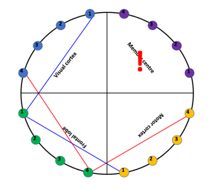
- What did you learn from the messages?
- How many of you read the Name of the new task on message 1?
- And how many of you to read the message with the instructions explaining how to complete that new task?

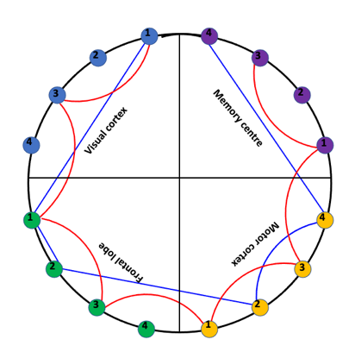
This activity demonstrates a Small World Network

- Lets try again, the 2 new messages are read by person 1 and n. Unlike before, you can either send the message to the same number in a different quadrant, your nearest neighbour, or your second neighbour.
- So you can use the rules from both the efficient and redundant network!
- You should end up with a network that looks something like this! This is a small world network

Repeat PART B: Do the same process as in Part A using the brain as a demonstration tool. Use Blue and Red ribbon wrap around the posts. Explain the process while demonstrating the network so it reinforces task Part A. Additionally stimulate a discussion surrounding what this task looks like and the efficiency of the network explained below.

So from this exercise where we’ve combined the features of the regular network and randomised network, we’ve realised or concluded (because we’re talking science) that we can have a network that is both efficient and redundant, therefore it is resilient to stress. So, the way to build defence against stress is to have a brain network that has lots of options, or lots of neural pathways. Resilience – Plasticity. So both long and short connect actions and as we've said before this type of network is called a small world network.

